## THILOTH B SHETTY

## 4MT19CS171

**Group1:**

1. Perform password cracking - Offline mode

a) Perform password cracking of windows 7 machine

Initially open windows and then open browser and search tmpfiles.org and later browse and add hash file that is been created upload it. Using the url obtained. Next step is to visit kali linux and browse tmpfiles.org along with url received then copy the file . open the command prompt and use command nano file name and paste the copied file and use john file name to obtain the result.

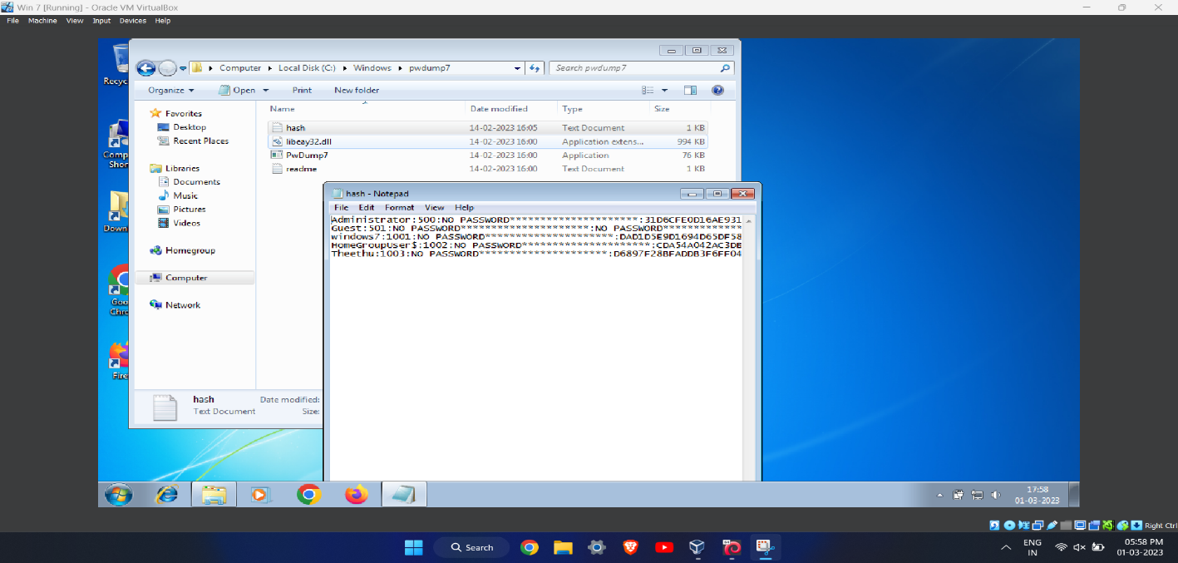

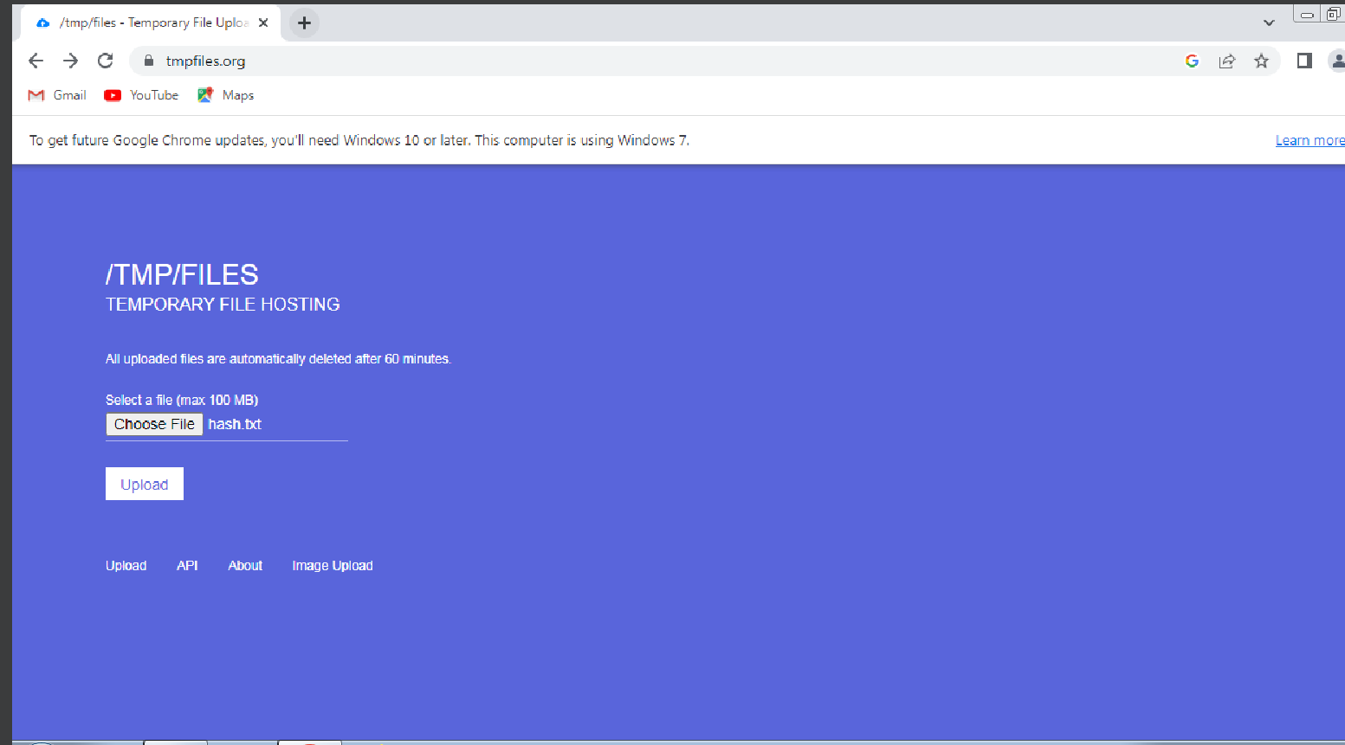

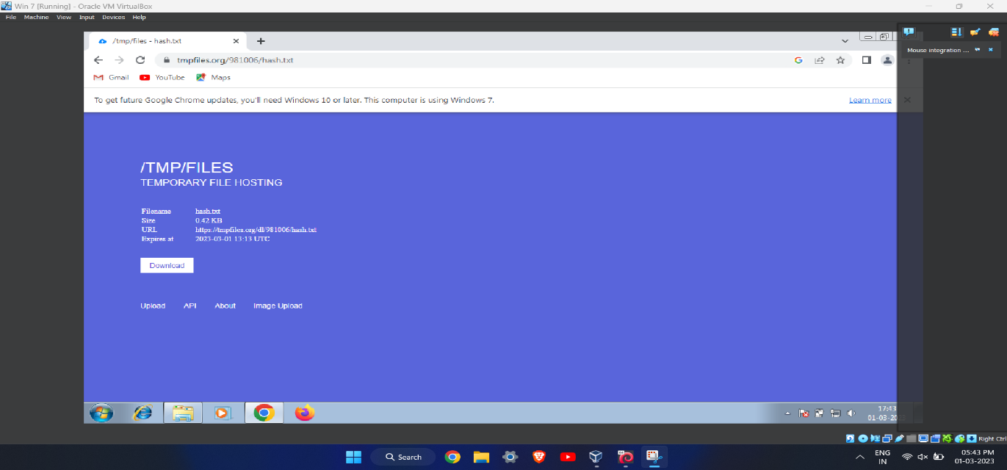

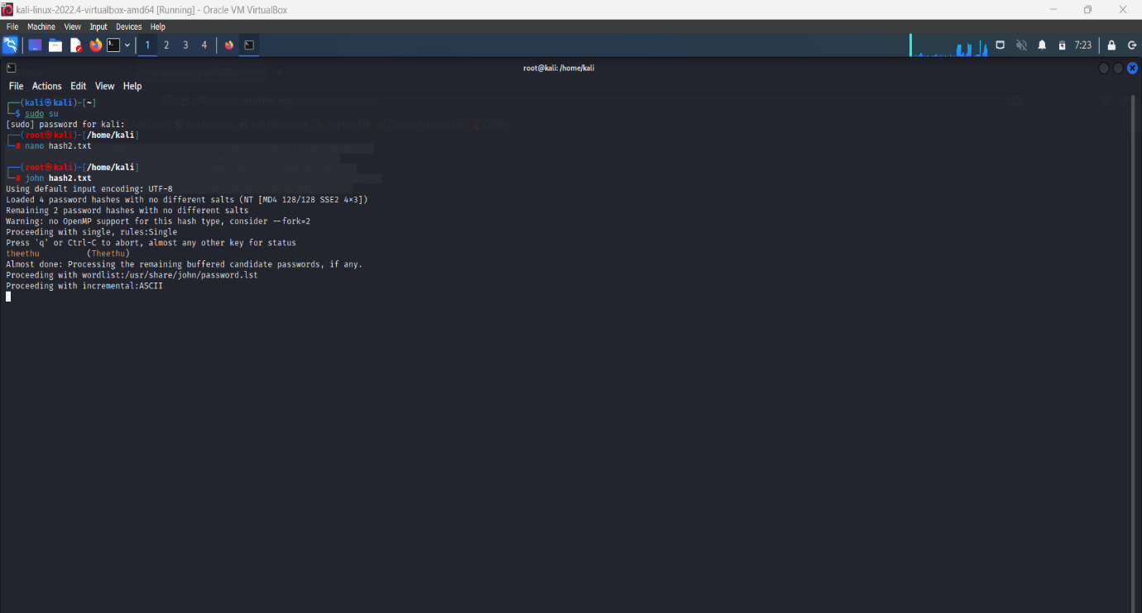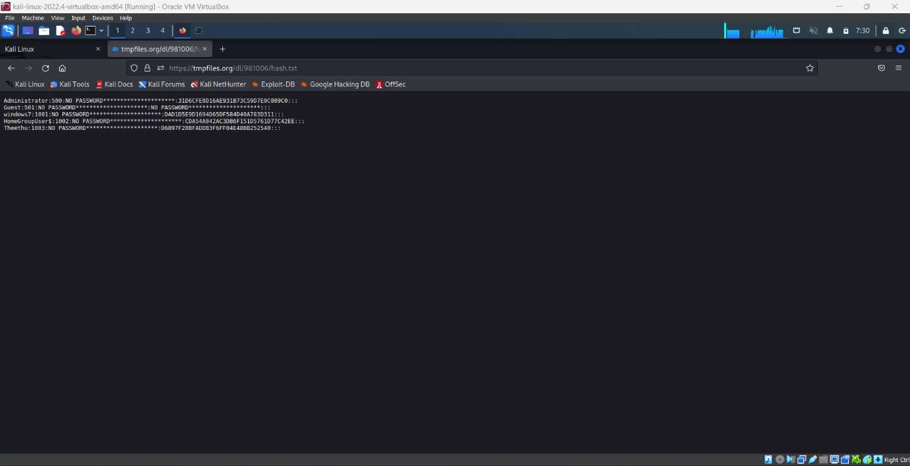

b) Password cracking of metasploit machine using Hydra

**Steps:**

Create a file using nano filename command

Use the tool hydra to know the user password and username. Note: If we are unaware about

username or password then use capital L(username) and P(password).

If we know username and unaware of the password then write the command as :hydra -lmsfadmin -

P pass .

If we know password and unaware of the username then write the command as :hydra -pmsfadmin

-L pass

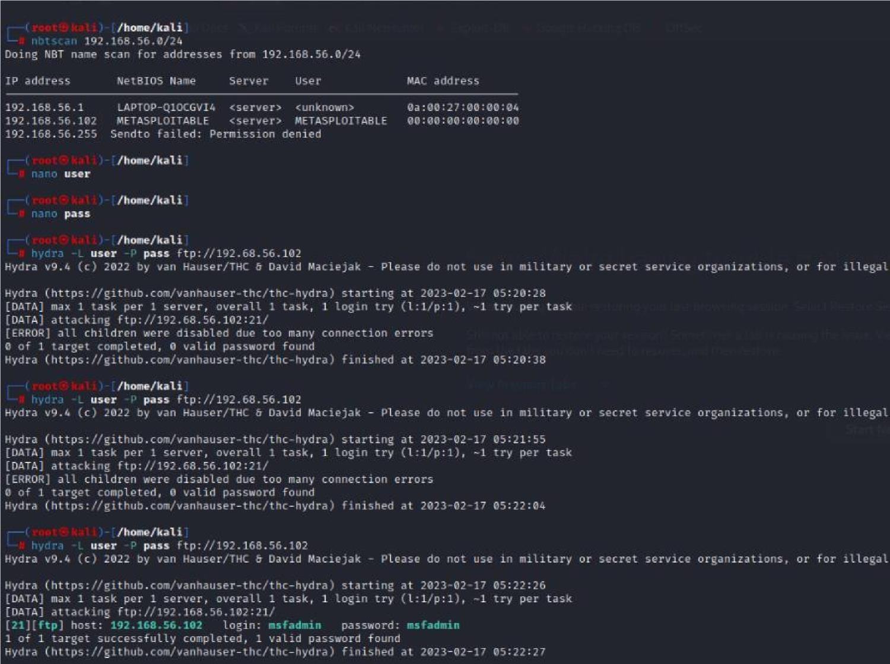

2. Perform password cracking of online vulnerable website(testfire.net) using Burpsuite

Initially enter the command Burpsuite it will redirect to another page.Turn on the intercept option in proxy.search for testfire.net in firefox and login using random username and password. Turn on the burp and then random password and username will be visible in the intercept. Copy the entire text which is available in intercept and click on send to intruder.copy username and password and click on add.Select the attack as cluster bomb attack and also set the payloads finally click on start attack.

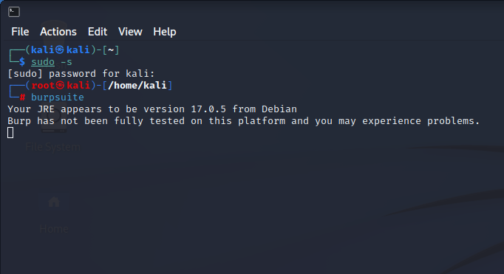

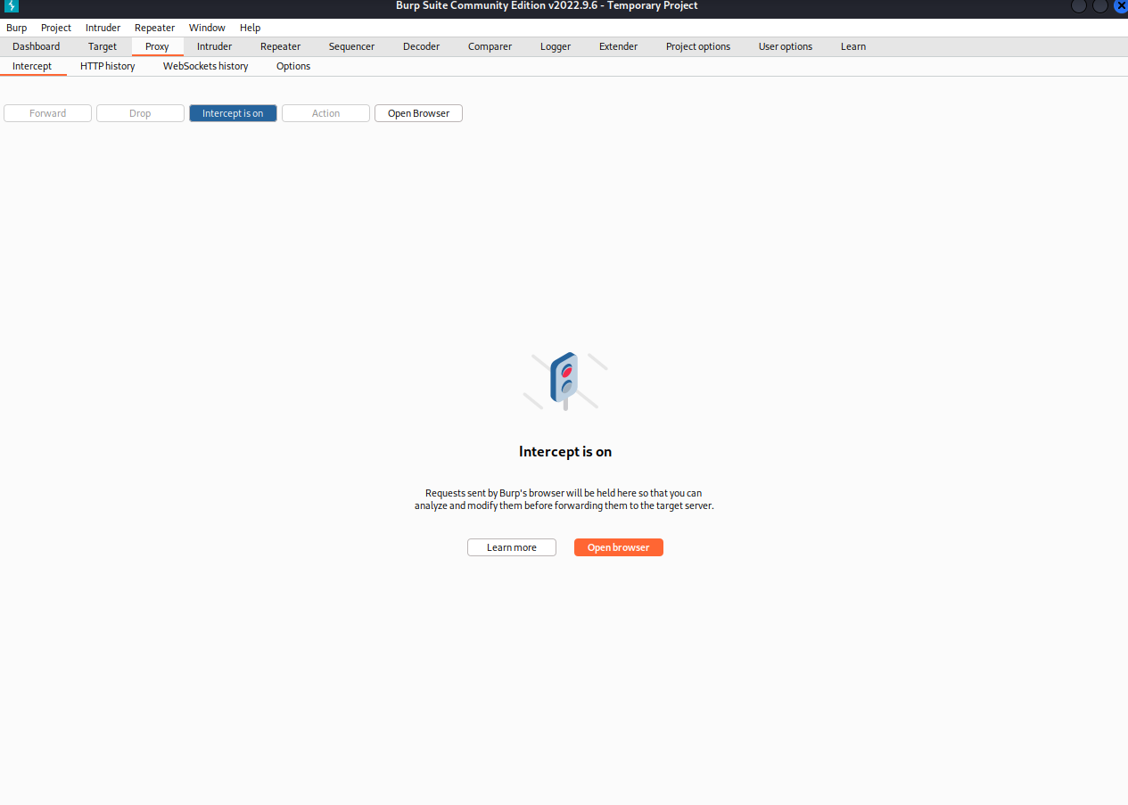

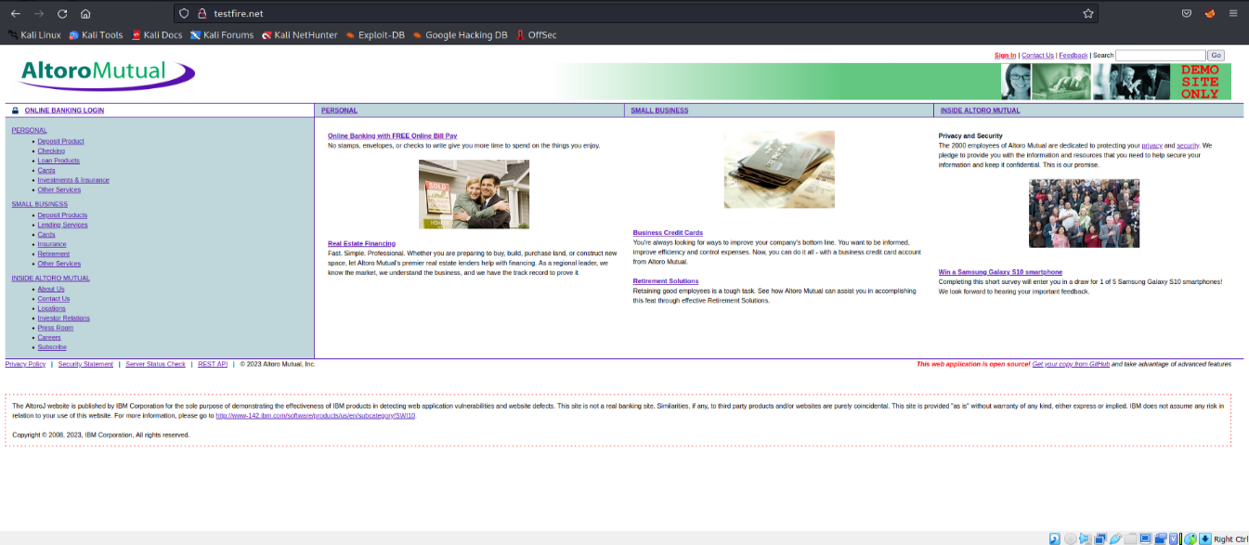

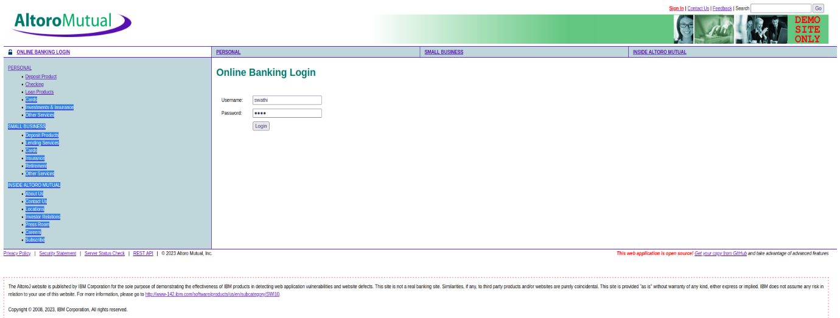

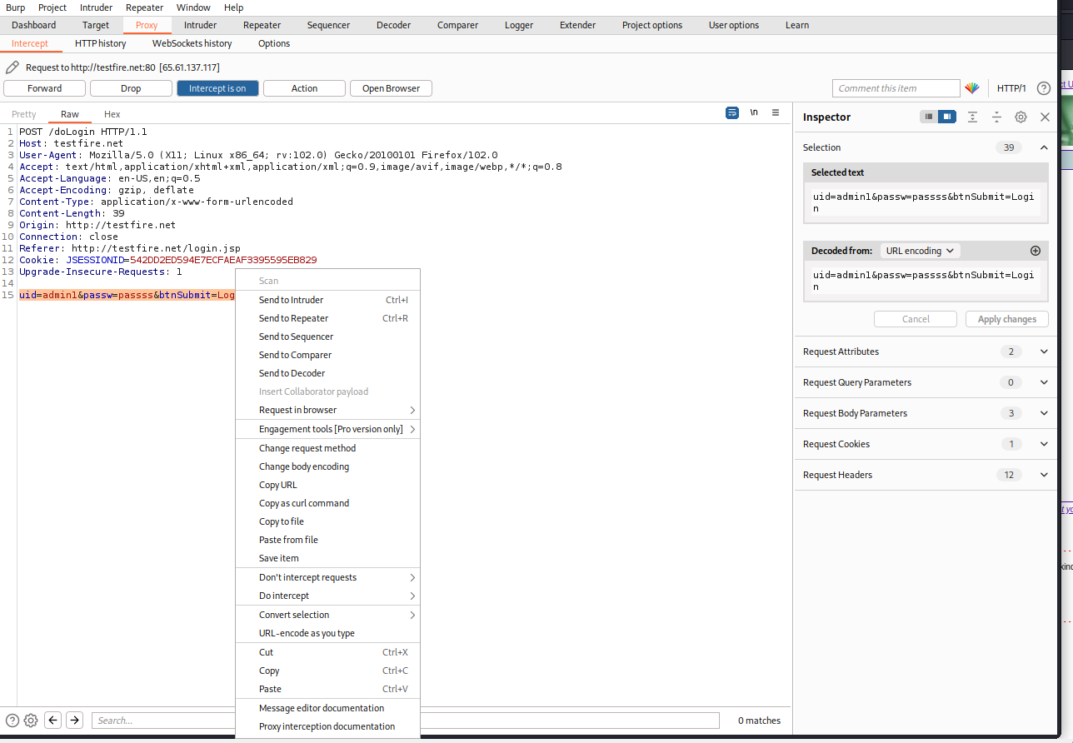

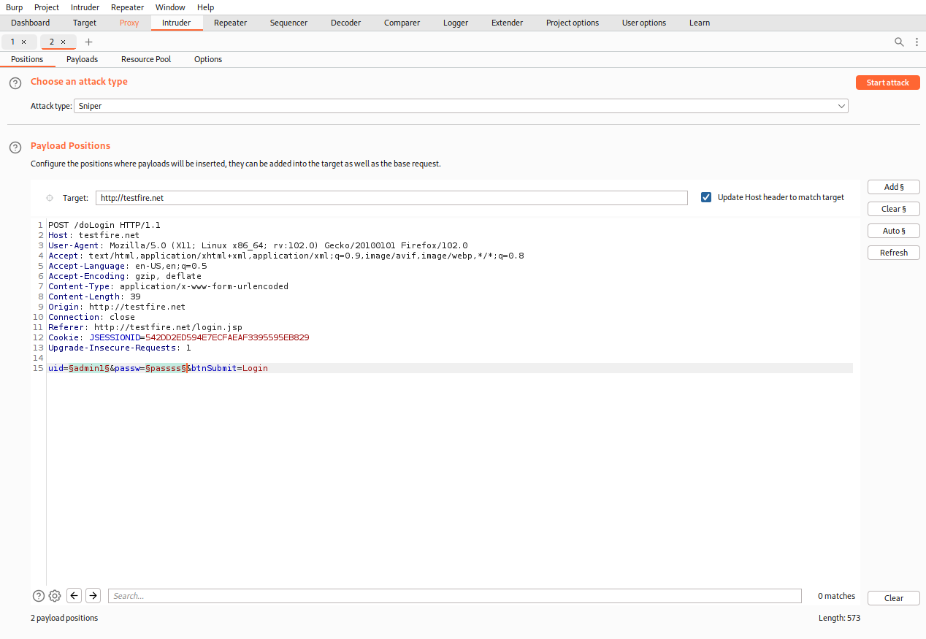

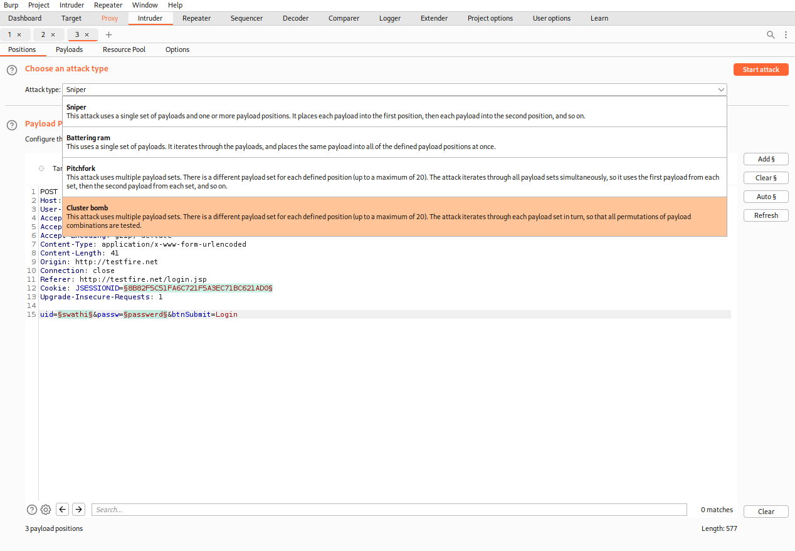

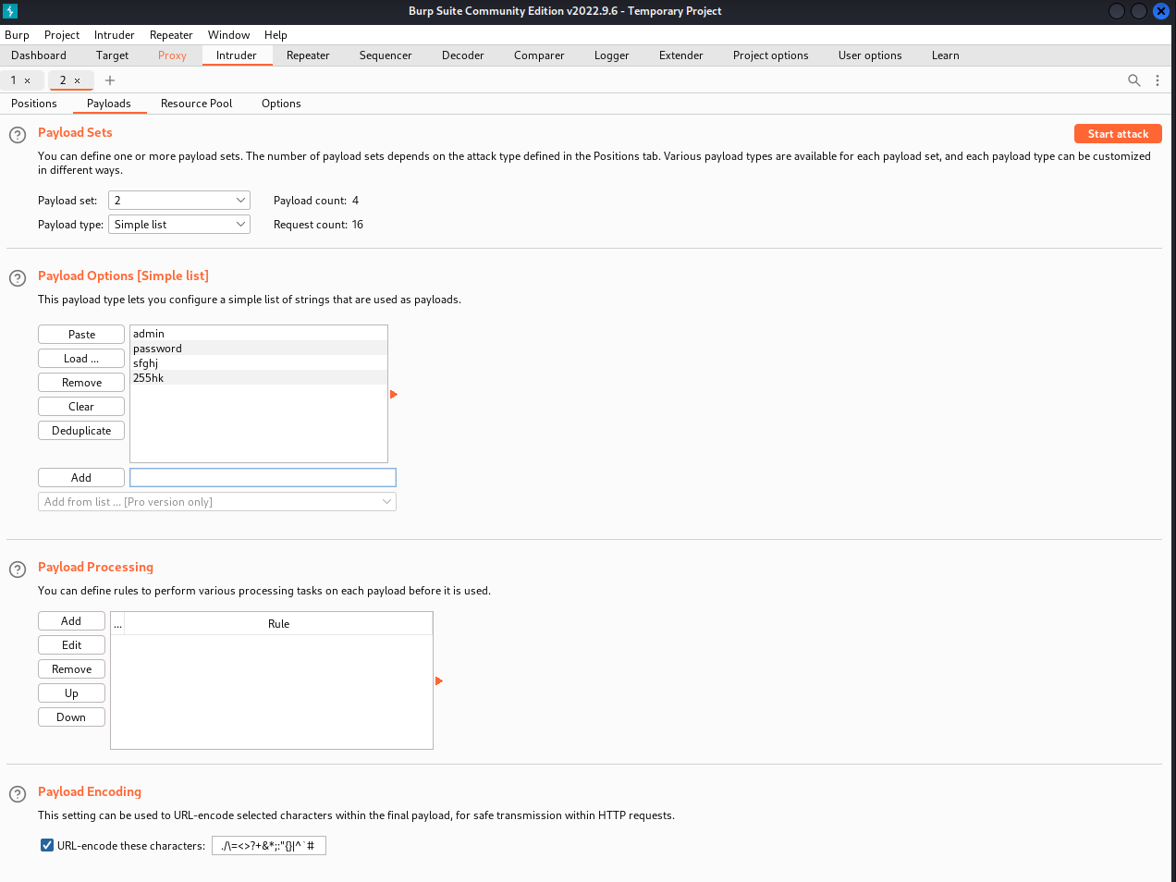

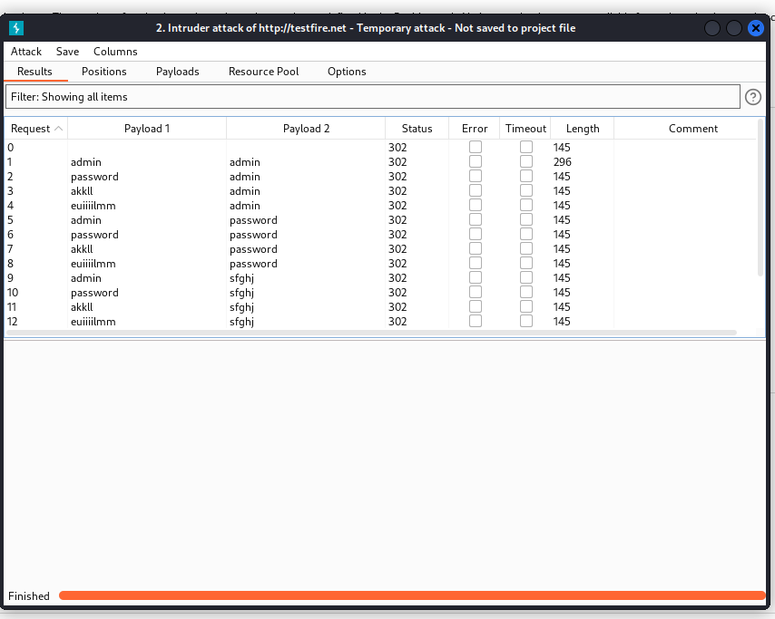

3. Perform Exploiting Metasploit

a) Exploiting Metasploit using FTP

* Enter the command $ sudo -s
* Enter the command nmap -sV followed by the target IP.
* Enter msfconsole.
* Enter the command search vstpd
* Enter the command exploit/unix/ftp/vstpd_234_backdoor which is available from step 4

o use exploit/unix/ftp/vstpd_234_backdoor

* Just enter show options
* set the value for RHOSTS so enter the command set RHOSTS 192.168.56.102
* Use show options in-order to check whether the RHOSTS has been updated or not.
* Enter the command show payloads
* We must set the payload as set payloads 192.168.56.102
* Enter the command exploit

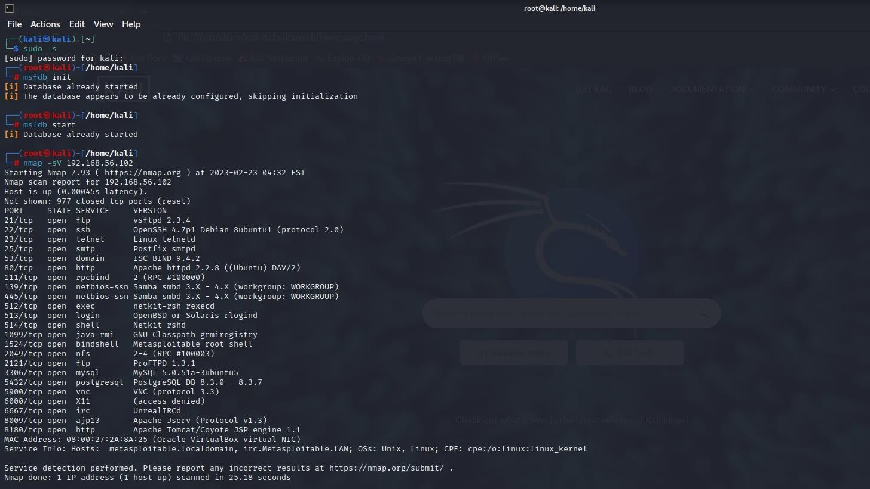

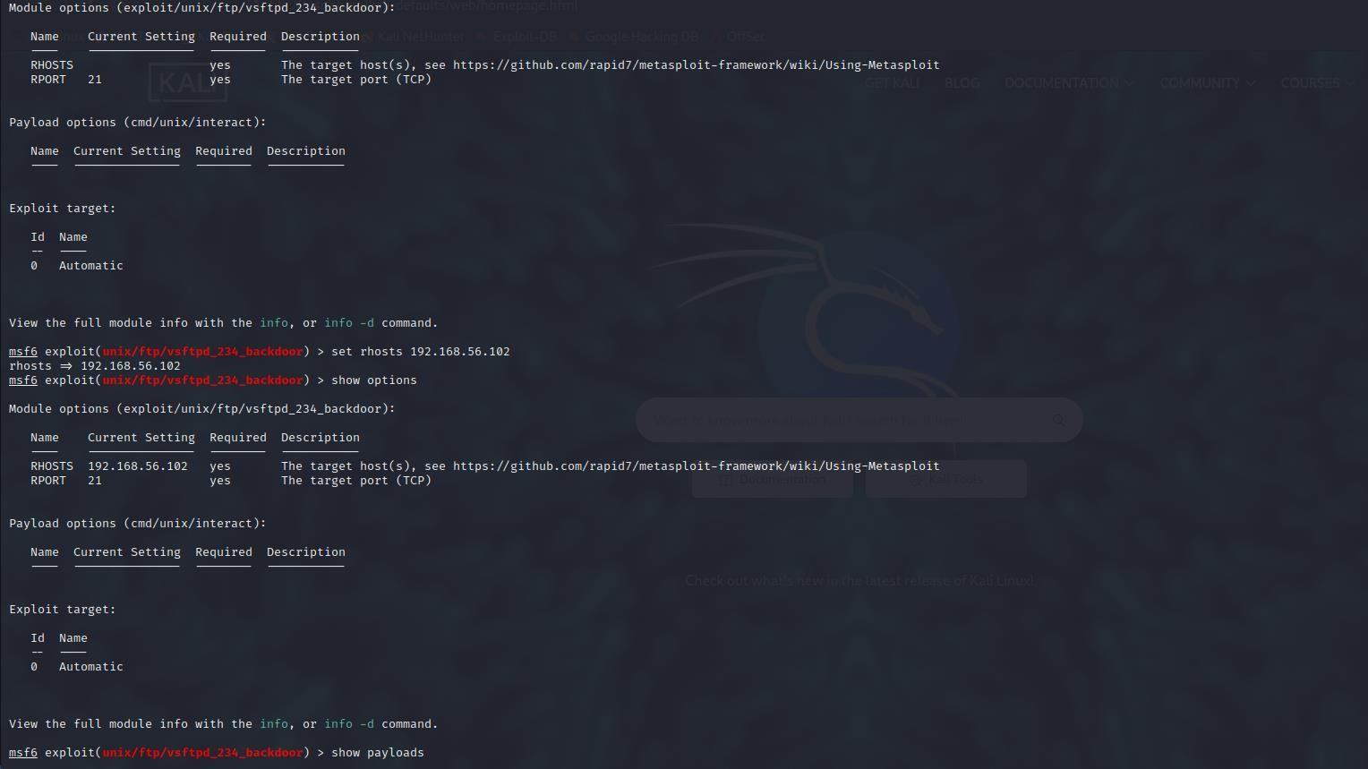

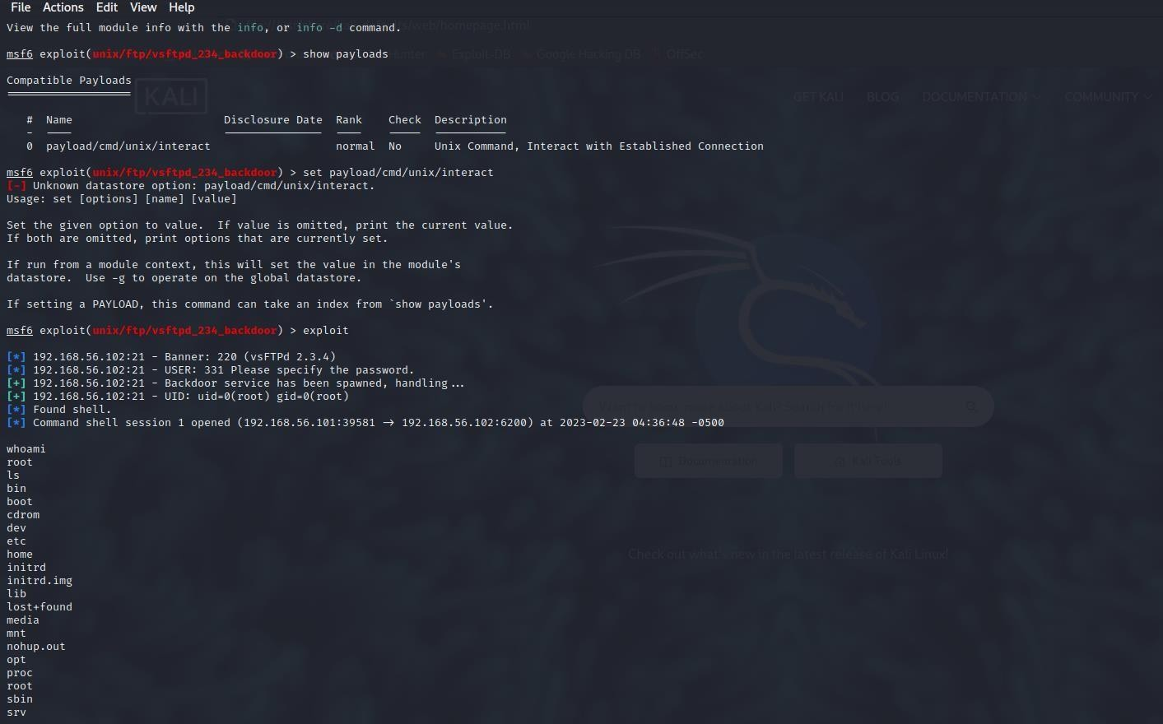

b) Exploiting Metasploit using SMTP

Using ifconfig to find the ip address of the kali linux and then using nbtscan to find the ip of the target that is metasploitable.

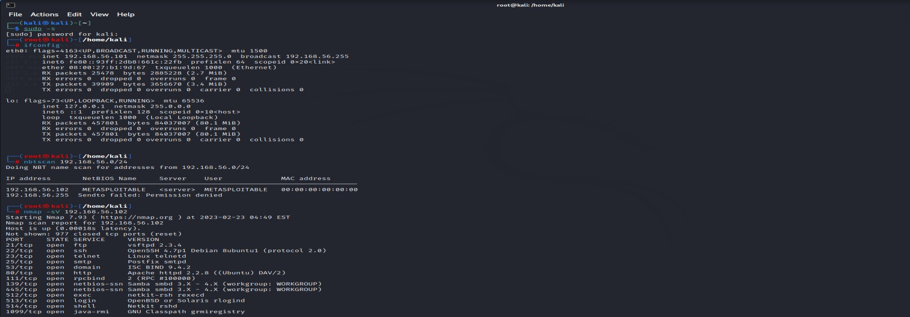

To find the port no and the version we use -sV along the ip of the target.

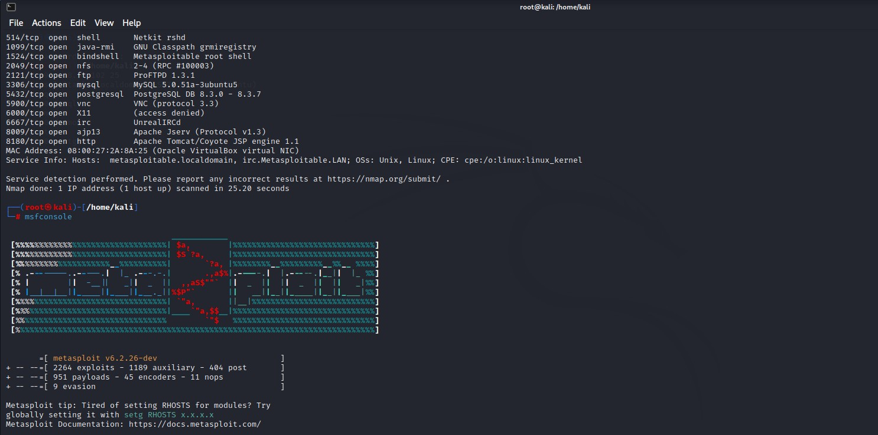

Using msfconsole and then used commad show options and then setting the RHOST using Rhost along with the ip of the target. Show options to check we have set the rhost and then use run command.

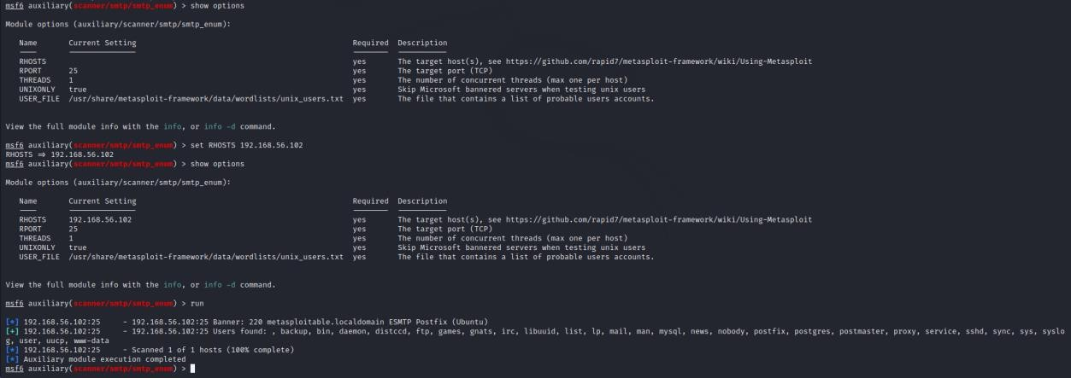

c) Exploiting Metasploit using Blind shell

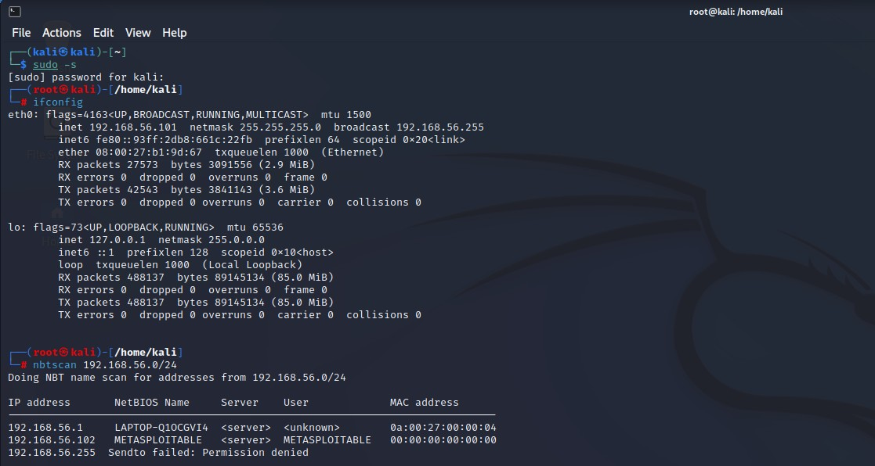

Using the nbtscan we are finding the ip address of the target.

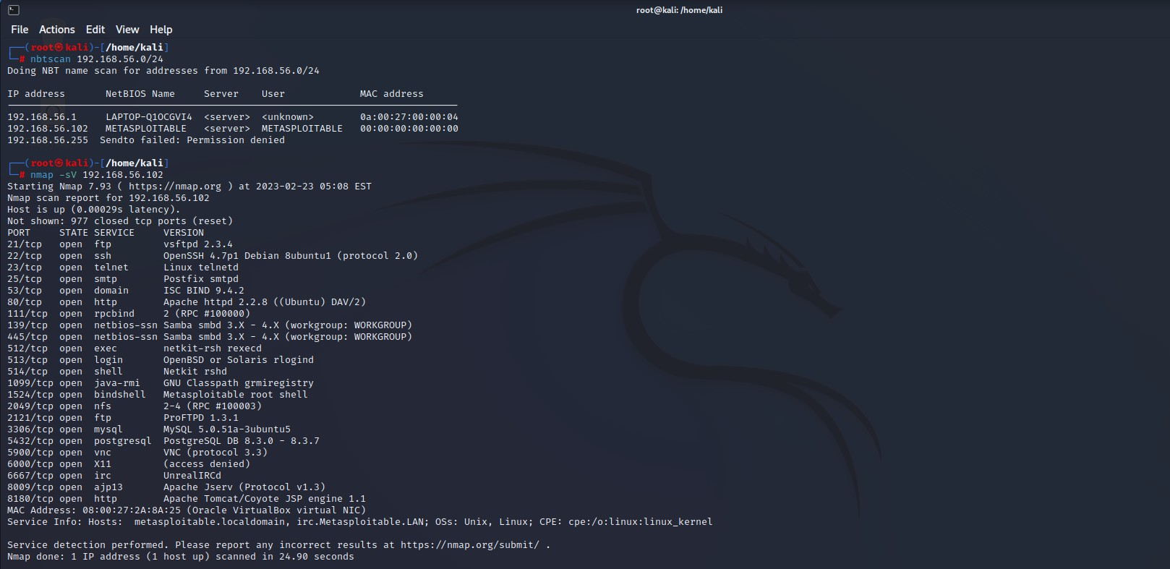

Nmap -sV is used to find the version service and port no of the connections, nmap -p is used to find the details of the bind shell port number. Using nc 192.168.56.102 1524

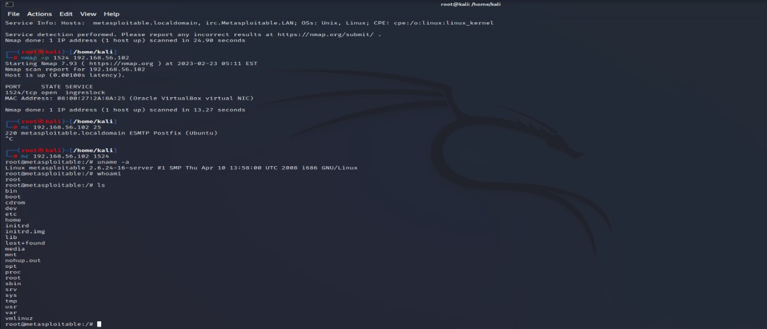

d) Exploiting Metasploit using HTTP

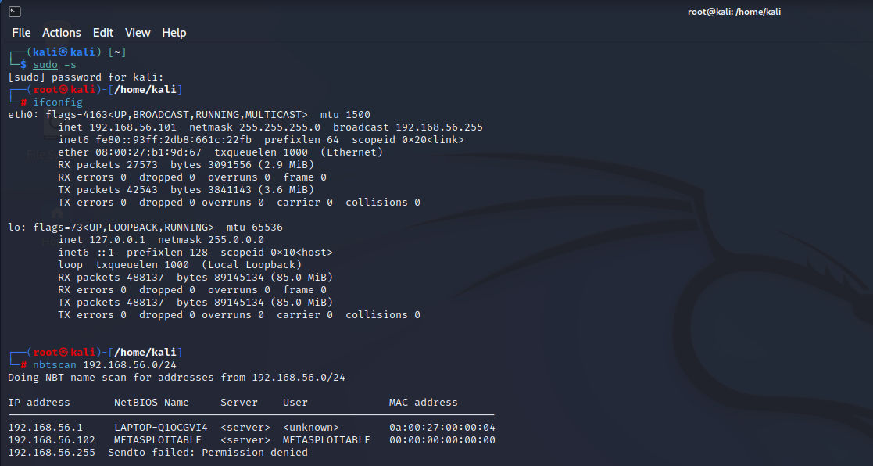

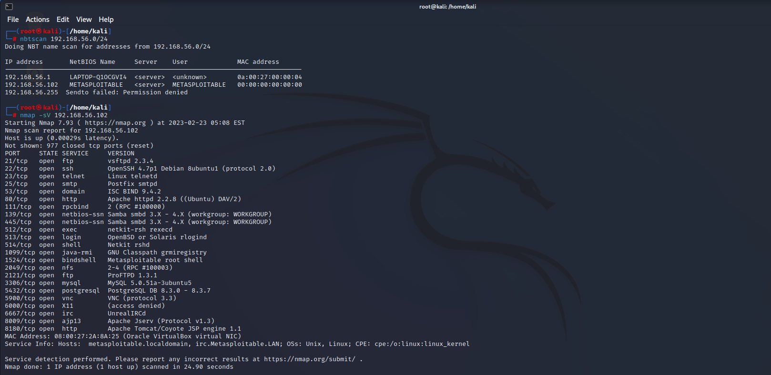

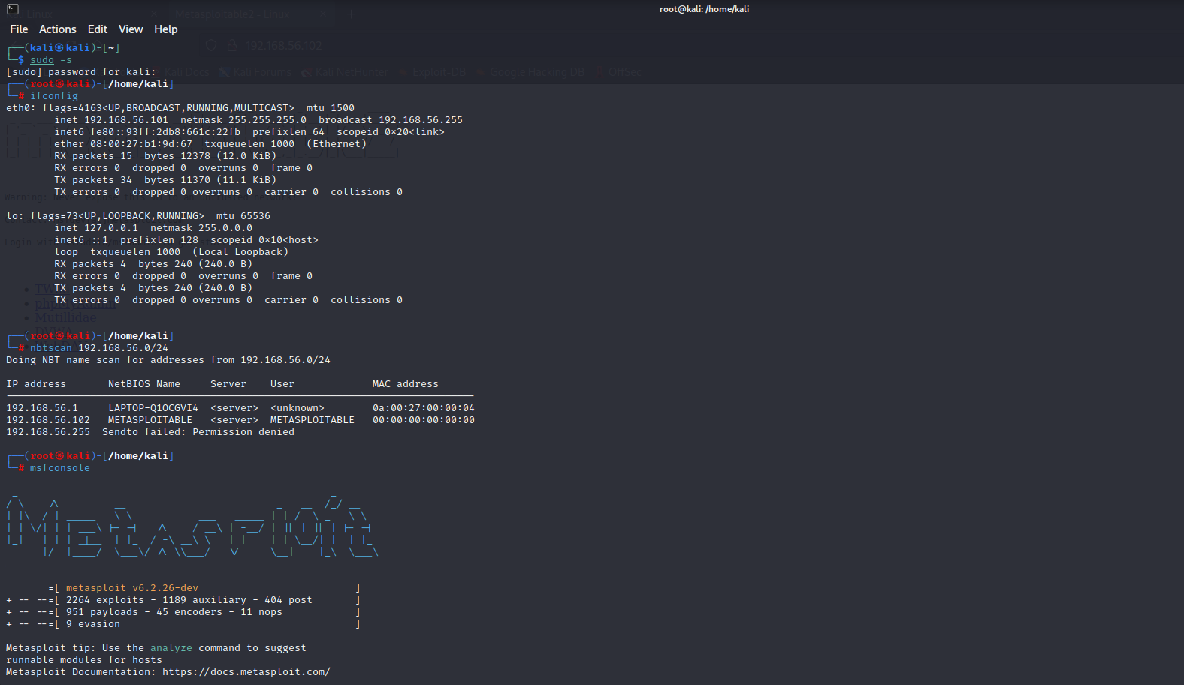

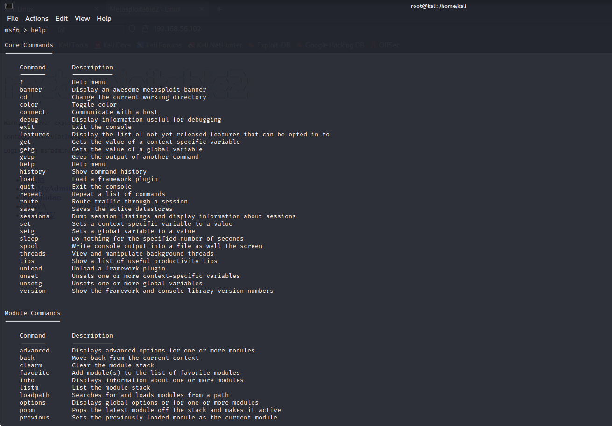

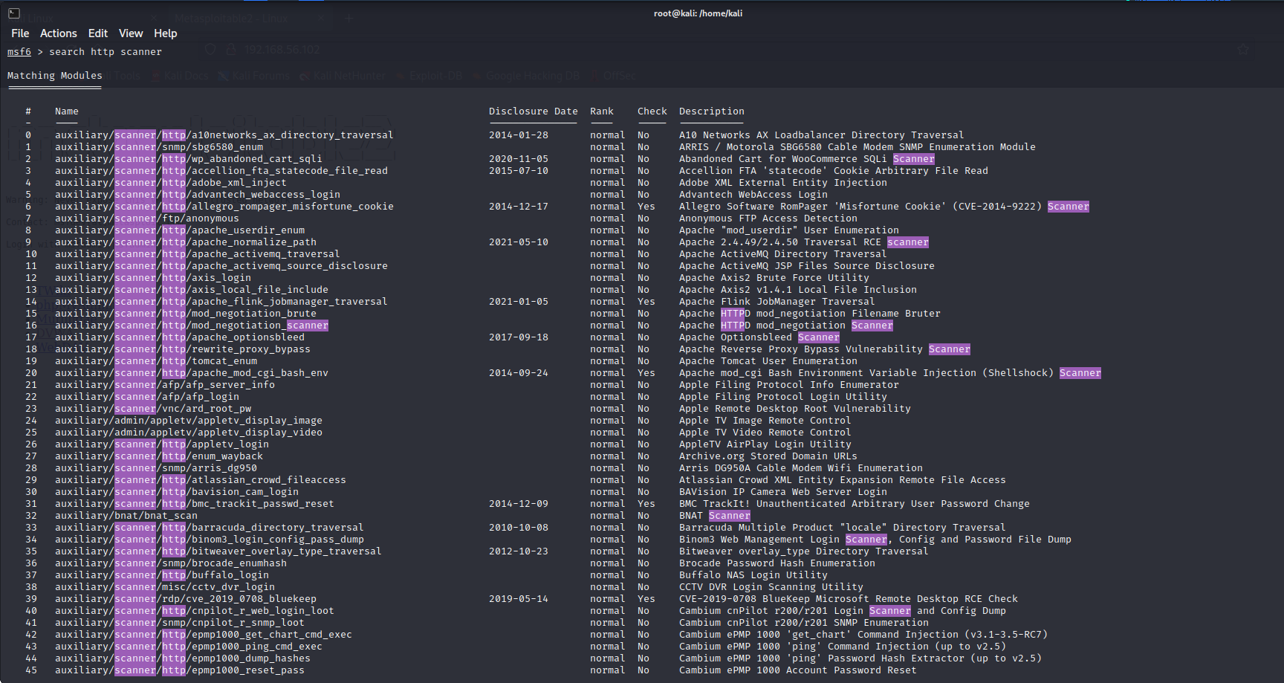

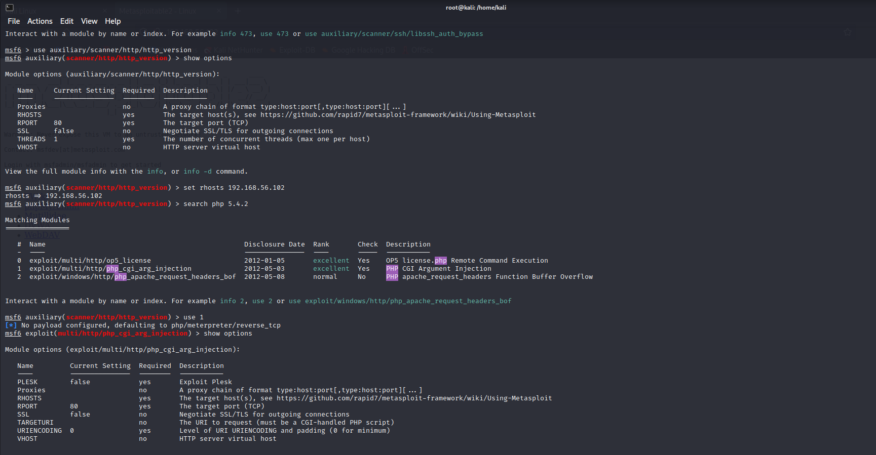

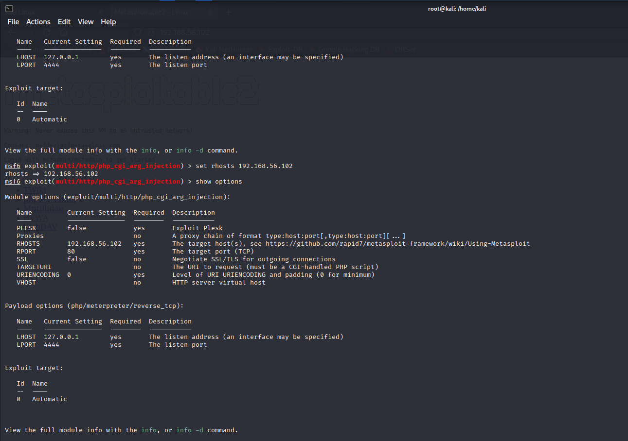

4. Perform Network scanning using following nmap commands:

a) nmap -p

b) nmap -sV

c) nmap -sT

d) nmap -O

e) nmap -A

f) nmap –Pt

First we use ifconfig in order to receive the ip address of the kali and then we use nbtscan in order to receive the ip of the target or metasploitable .



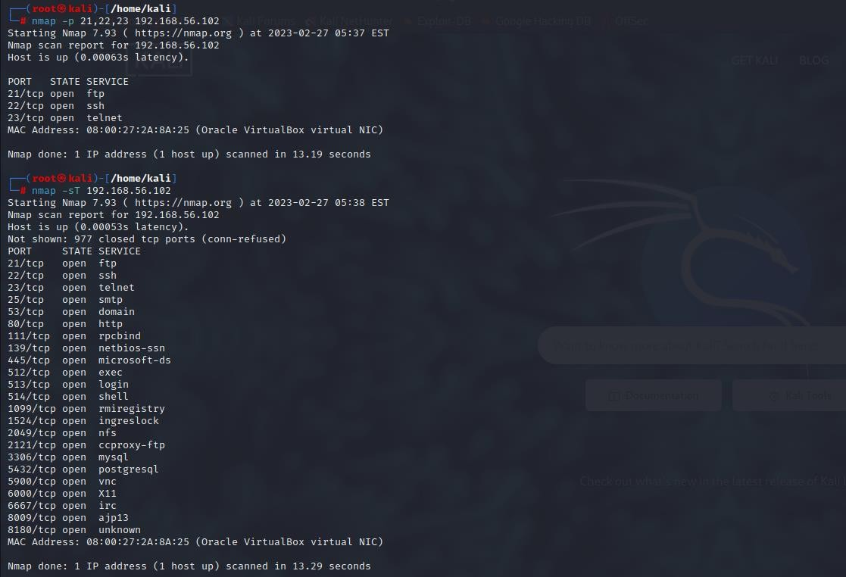

Nmap -p is used to scan the port , we can also use the -p along with port no in order to obtain the details of the port like service , state.

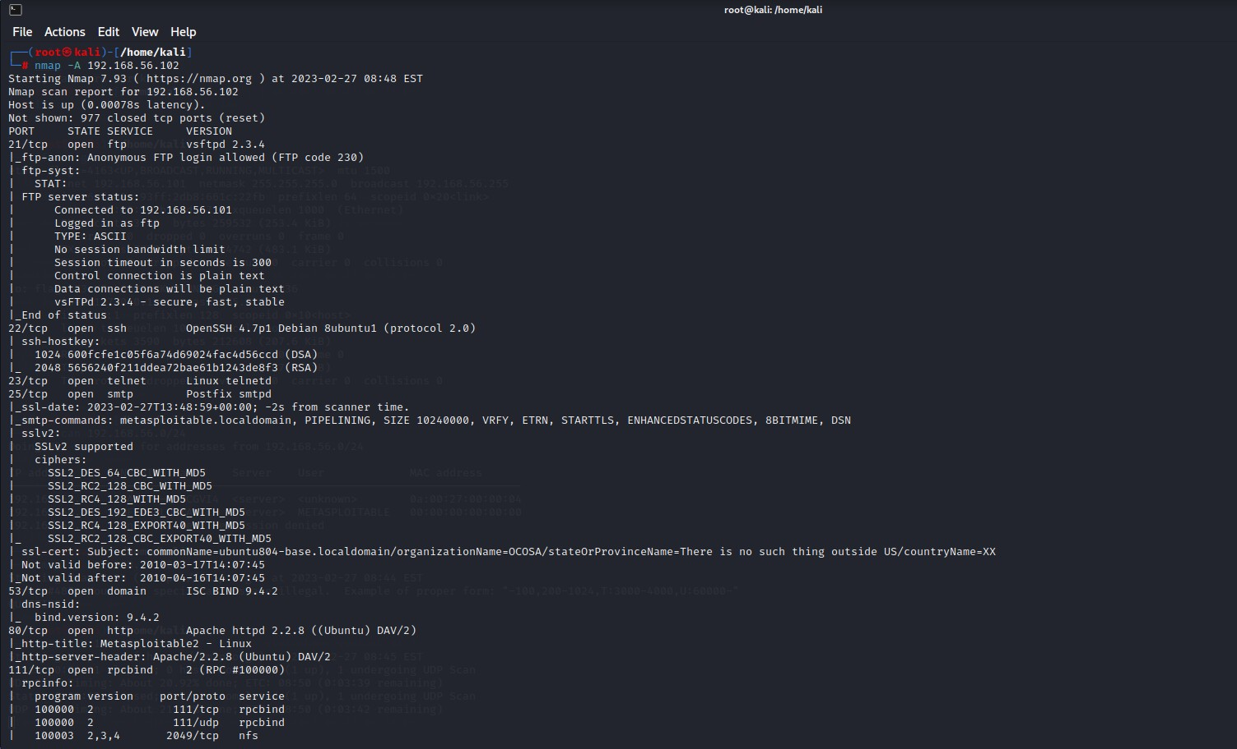 Nmap -sT is used to scan the tcp port and -sU is used to scan the udp port.

nmap -A is a aggressive scanning it performs aggressive test such as remote OS detection. Service or version detection.

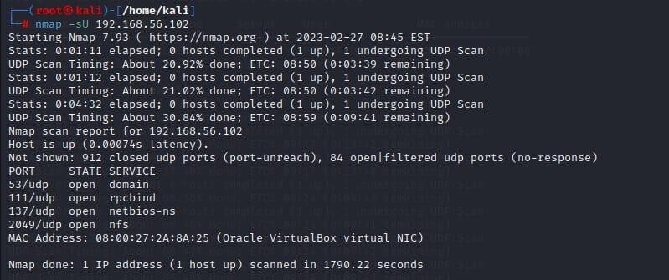

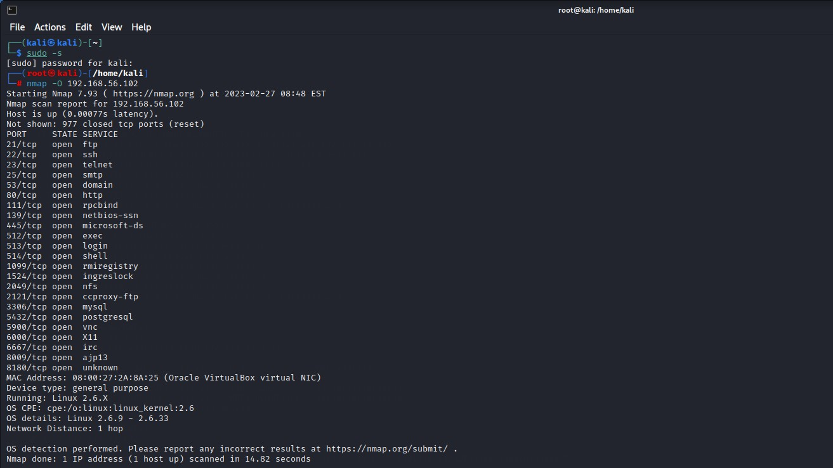

nmap -sU is used to scan the udp port and get the complete details.

5. Networking project on Fire extinguisher using cisco packet tracer.

Fire Extinguisher project is done using the cisco packet tracer. Cisco packet tracer is a network simulation tool. This project is used to control the fire and to activate the filter when there is smoke detected beyond the range specified.

To implement this we required mainly 4 components they are a server, water sprinkler, smoke detector, and 3 cars that emits the smoke.

**Steps:**

* Drag and Drop Server pt,Access point,Smoke detector,lawn sprinkler sprinkler,old car-3.
* Rename Server pt as *"Registration Server"* and Rename lawn sprinkler sprinkler as "*lawn sprinkler IOT-0".*
* Double click on Access point and select config then select port1 and write *"SSIO"* inplace of CISCO .
* Double click on server and select desktop then select IP config then select *"static"* & also write IPv4 as *"1.0.0.1"*
* Double click on Smoke detector and select config then select wireless0 and write *"SSIO"* inplace of CISCO & also select IP config as *"static"* and IPV4 as *"1.0.0.2"*.
* Double click on Sprinkler and select config then select wireless0 and write *"SSIO"* inplace of CISCO & also select IP config as *"static"* and IPV4 as *"1.0.0.3"*
* Now connect access point to registration server using symbol
* Double click on Sprinkler and select settings and then select Remote Server and write server address as *"1.0.0.1"* ,username:"*admin"* & password :"*admin"* and press *connect*.
* Double click on Smokedetector and select config and then select settings and then select Remote Server and write server address as *"1.0.0.1"* ,username:"*admin"* & password :"*admin"* and press *connect*.
* Add IPaddress for Registration Server as *"1.0.0.1"*,Smoke detector as *"1.0.0.2"* & Lawn sprinkler IOT-0 as*"1.0.0.3"* .
* Now double click on Registration server and select services and select IOT and select *"on"*.
* Now double click on Registration server and select Desktop and select web browser and in url type as *"1.0.0.1"* and press go.
* Now select *"signup"* and type username & password as "*admin" then press create.*
* Select *"conditions"* and select add and type name as *"smoke on"* and then set the level as *">=0.4"*

and select sprinkler status *"true"* and then press ok.

* Select *"conditions"* and select add and type name as *"smoke off"* and then set the level as *"<=0.4"*

and select sprinkler status *"false"* and then press ok.

Now done with establishing [connection. To](http://connection.to/) obtain the smoke press ALT+car.

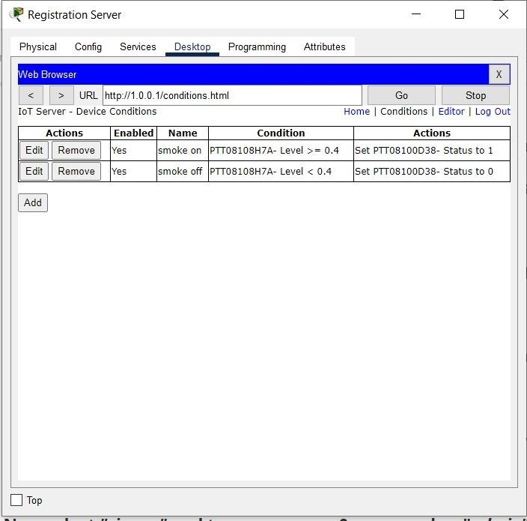

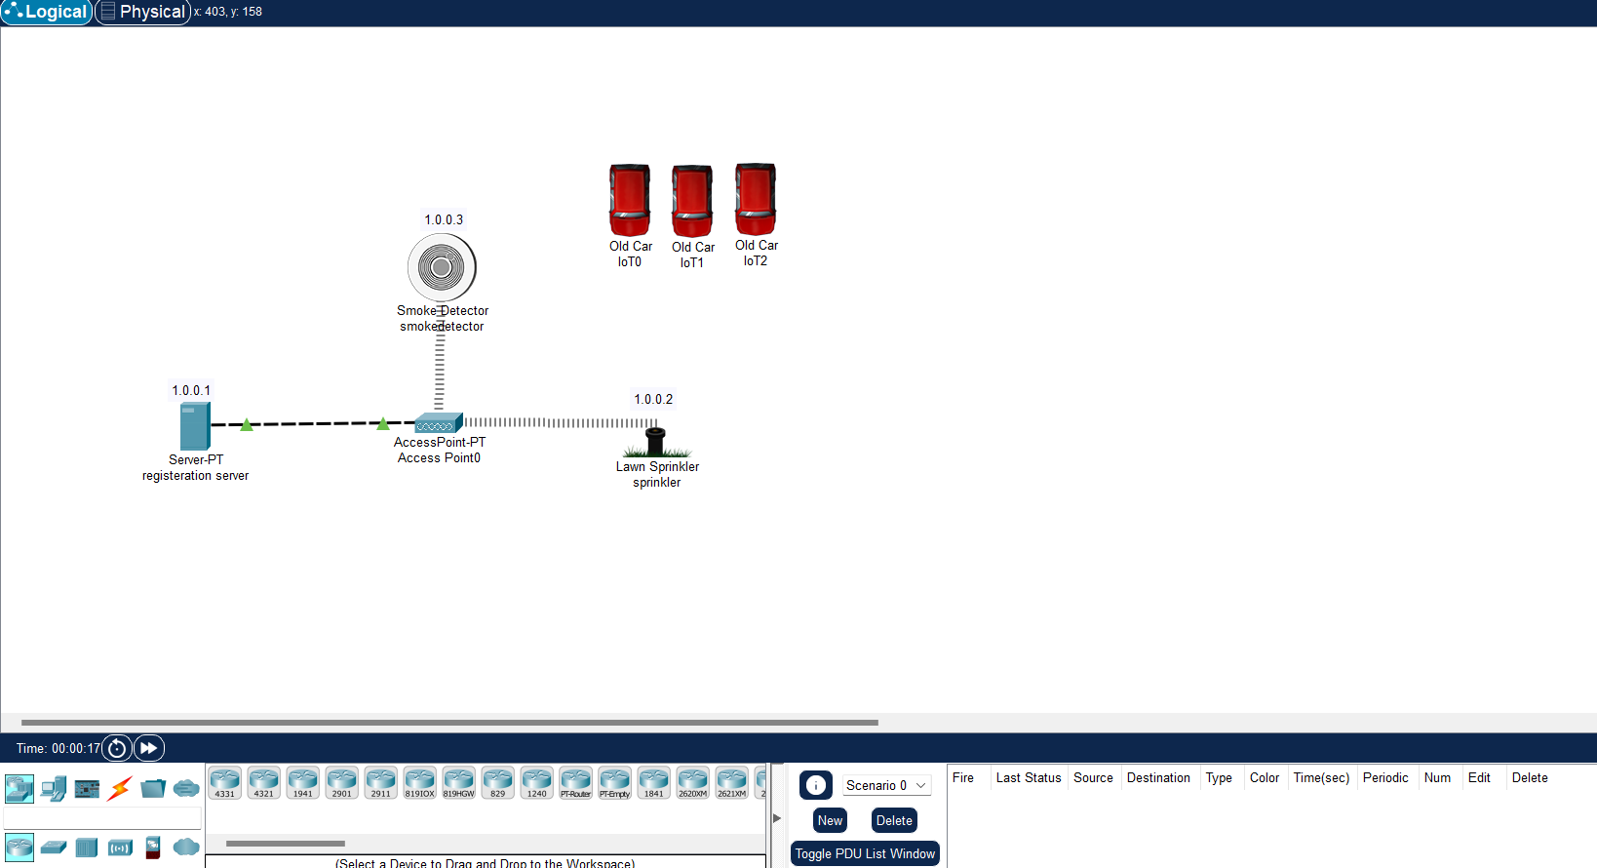

**Group2:**

1. Perform exploiting DVWA

a) Perform SQL injection on DVWA

b) Perform Cross-site scripting on DVWA

c) Perform File upload DVWA

Step 1: Find the IP address of the pc using- ifconfig. Then find IP of Metasploit using - nbtscan.

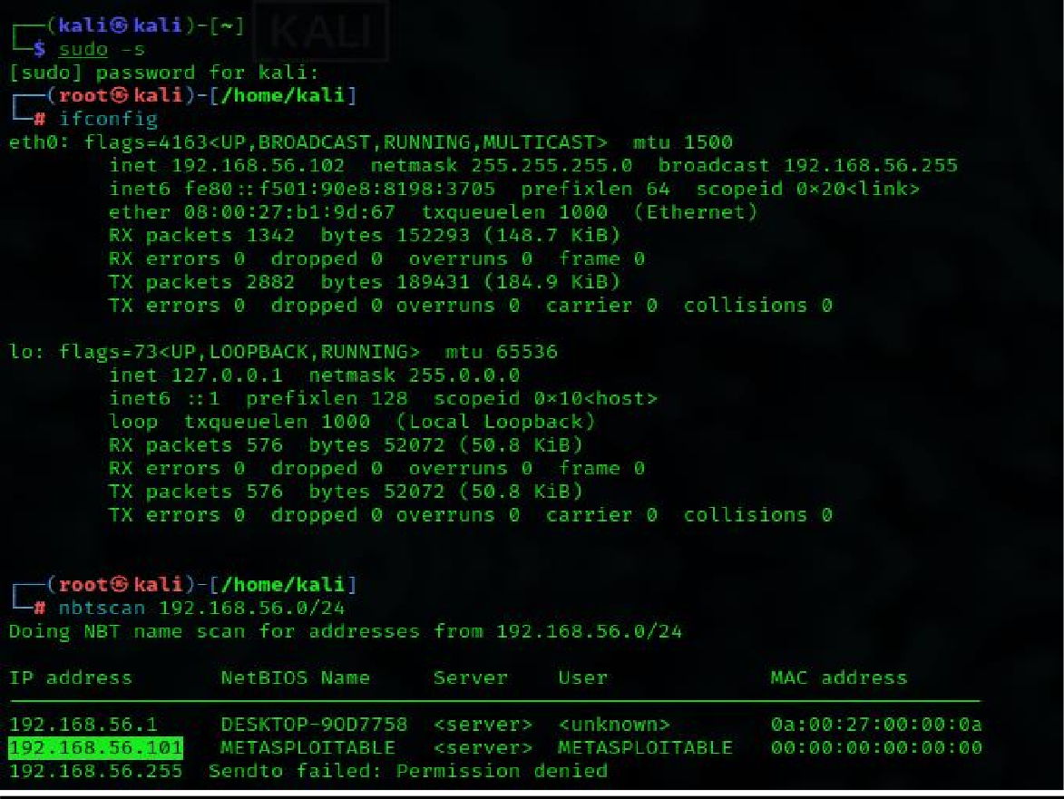

Step 2: Copy the IP of Metasploit and paste it in Firefox. Choose the DVWA in order to find the vulnerabilities.

Enter the username and password –

(ie. username: admin, password: password)

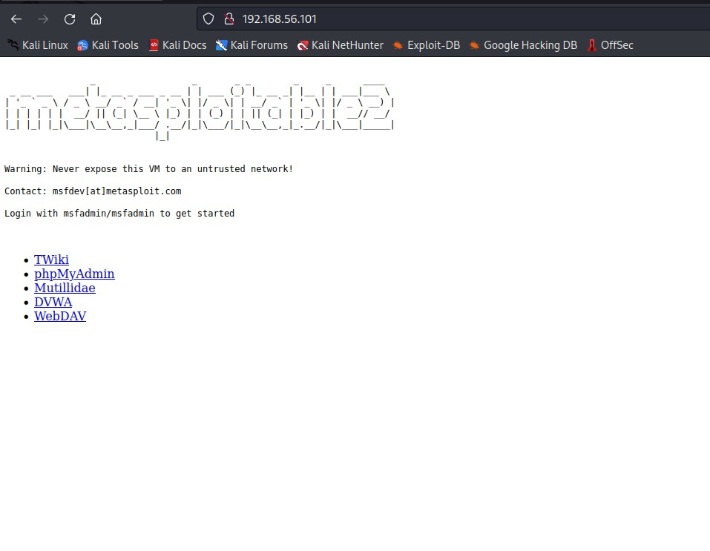

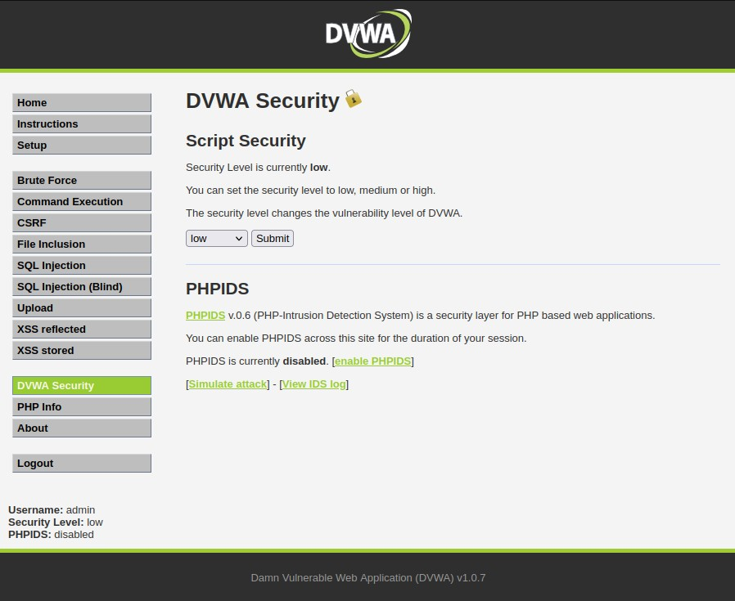

Step 4: SQL Injection – Process by passing the queries, so that we can get unauthorized access.

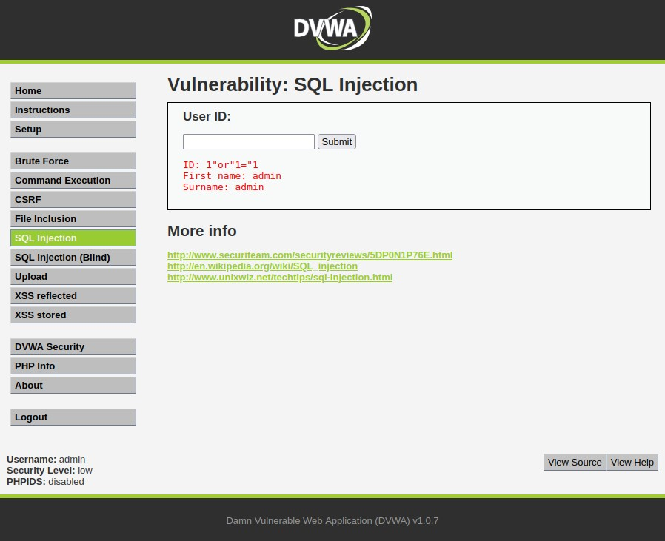

Step 5: SQL Injection (Blind)- also a kind of SQL injection used to attack data- driven applications using SQL statements. SQL statements are inserted into an entry field for execution.

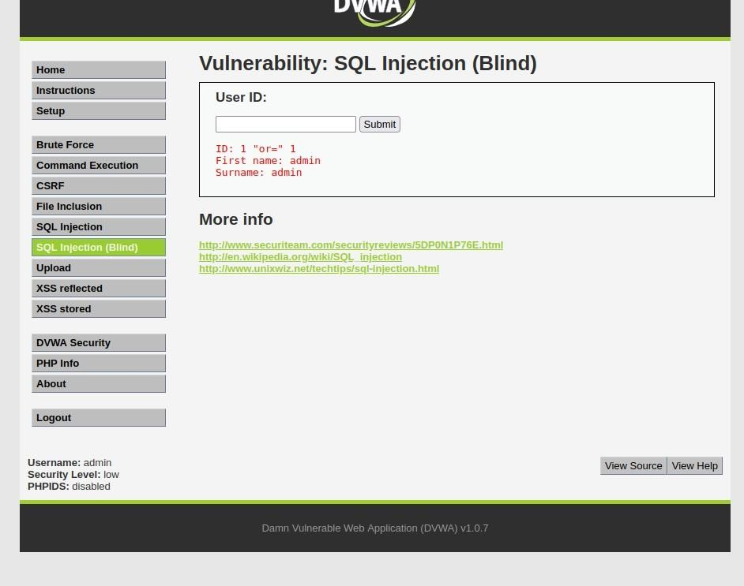

Step 6: XSS reflected-Used to add the script

<script>alert(“hacked”) </script>

This change will be for temporary period.

Step 7: XSS stored -Used to add the script but the effect here is permanent.

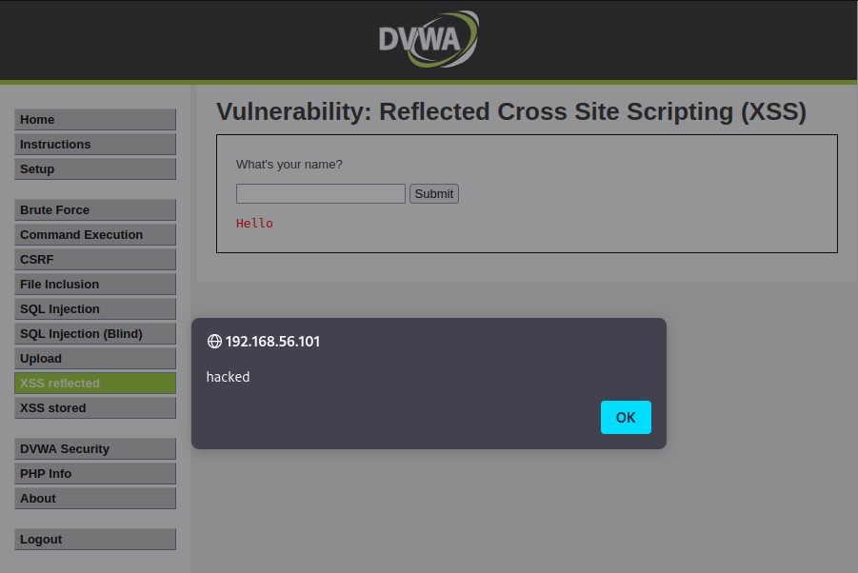

Step 8: To check the vulnerability in the upload. We can upload any files that cause damage or hacking. If the website or any form doesn’t specify the document type, we can easily add any scripts or txt format in order to hack.

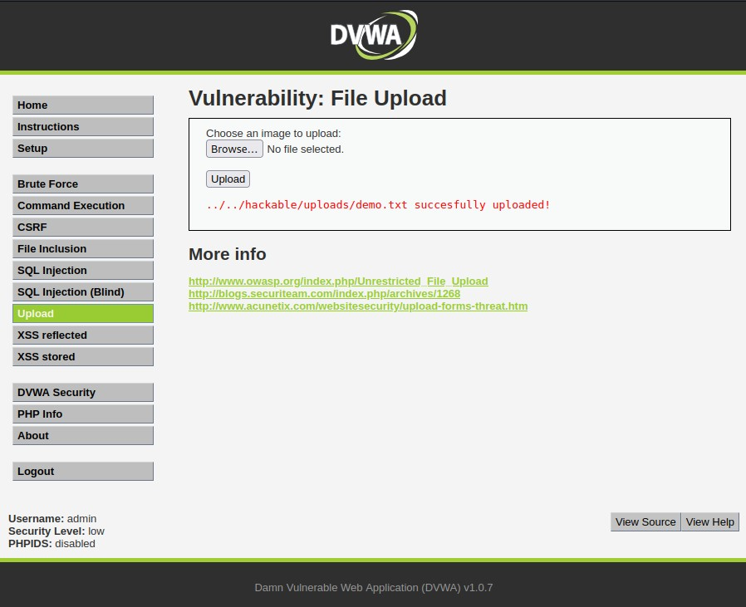

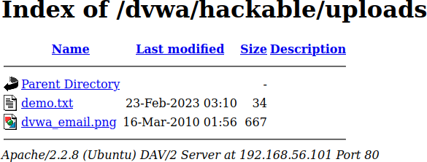

2. Perform Sniffing

a) Perform Sniffing using Wireshark in kali linux

* + Getting super access using the command $ sudo -s
  + Enter the command wireshark in the kali
  + Meanwhile it will get opened in the separate page
  + Search for testfire.net in firefox.
  + There we should sigin using the username and password. The you will be directed to another page.
  + Select eth0 which we get from the wireshark. Then enter http on top of the page.

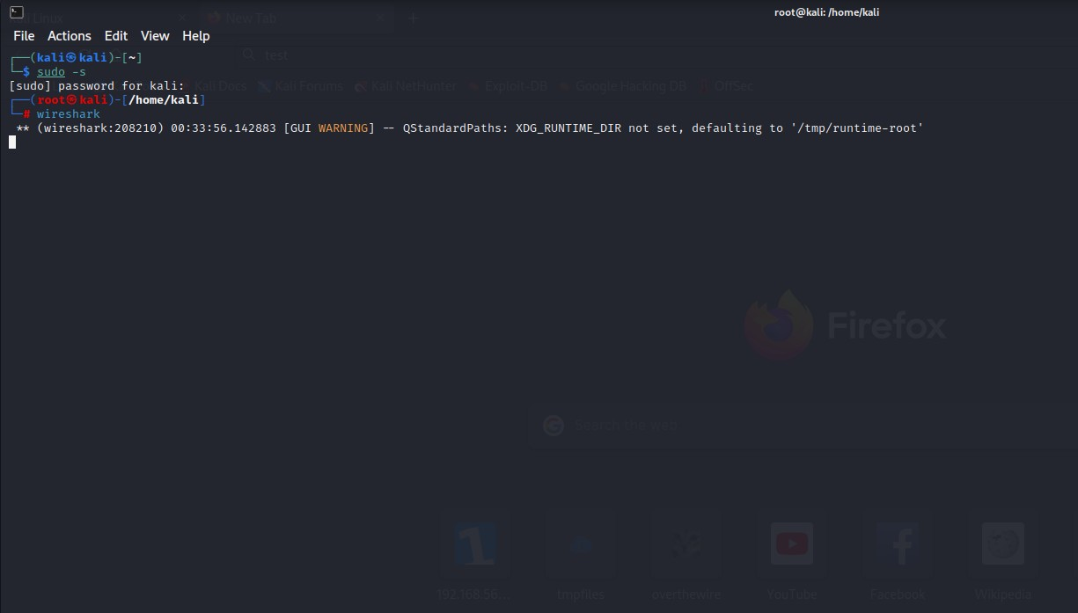

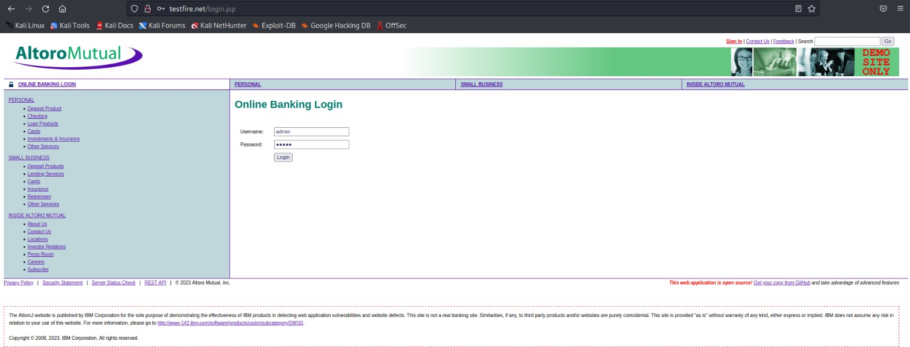

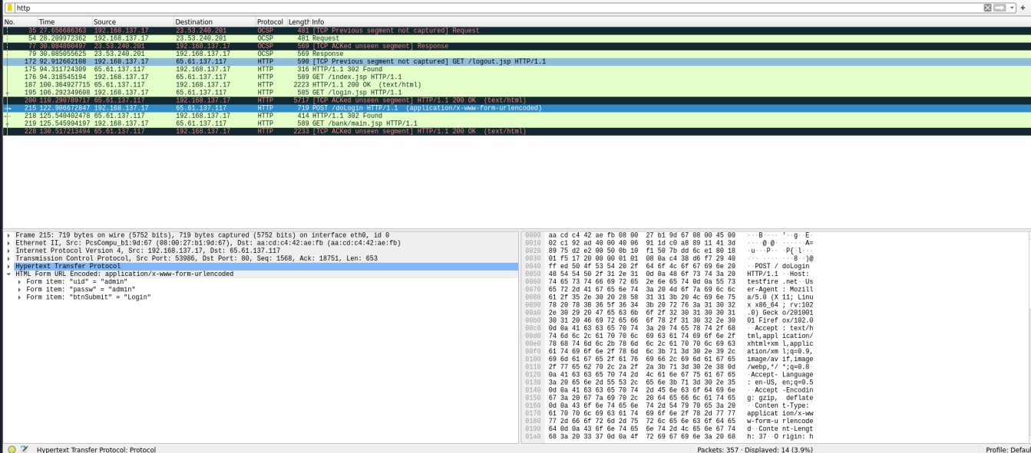

b) Perform Sniffing using Ettercap in kali linux

* Getting super access using the command $ sudo -s
* Check the IP address of the targe using ifconfig.
* Enter the command nbtscan, it is a program for scanning IP networks for NetBIOS name information. nbtscan 192.168.56.101.
* Enter the command Ettercap -G.
* There you get a checkbox opened set snipping startup.
* Click on the 3 dots on top of Ettercap window and choose host and select and scan for the hosts.
* Once again click on host and choose hostlist.
* Click on the globe icon choose for ARP poisoning. Then set IP of windows to target1 and IP of metaspoiltable to target2
* In metaspoiltable enter the command ping followed by the windows IP to check whether the connection is built or not.
* Enter the IP of the target i.e 192.168.56.102 in firefox of windows7. There you get a DVWA page. Just login using the username and the password.

